**Report: Retail Sales & Customer Insights Dashboard**

**Background**

XYZ Retail, a mid-sized retail chain specializing in apparel, electronics, and household items, struggled with optimizing sales performance and understanding customer preferences. The company relied on traditional sales reports, but they lacked real-time analytics, to tackle these challenges, XYZ Retail implemented a **Retail Sales & Customer Insights Dashboard.**

**Workflow:**

**Database Creation**:

* Created a database ‘retail2’ in MYSQL Workbench.
* **Star Schema Design –** Build a warehouse schema to optimize queries for inventory and supply chain management.
* I have created tables in the database using ‘star schema’ design.
* I created total 5 tables – 4 dimension tables and 1 fact table.

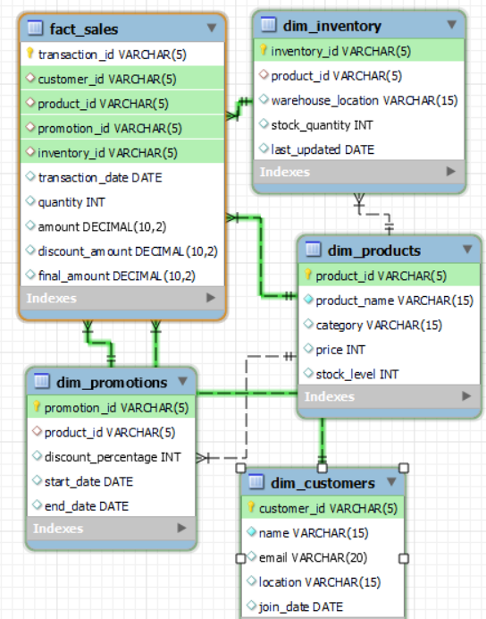

* dim_customers, dim_products, dim_promotions, dim_inventory, fact_sales are all tables..
* For inserting the data I have made some assumptions.

1. Products – 5
2. Customers - 5
3. inventory – 5

* I inserting the data of 12 sales.

**Data Analysis Using Python Pandas**

* Now I have connected the python and database tables using sqlalchemy library using engine.
* Load the database tables into Dataframes using pandas.
* Dispose the engine to close database connection.

**Customer Lifetime Value (CLV)** to identify high-value customers

* grouped customer id from sales dataframe to find the total revenue and purchase count and saved it in clv dataframe.
* Merged the clv and customers dataframe based on customer id column.
* Dropped unwanted columns.

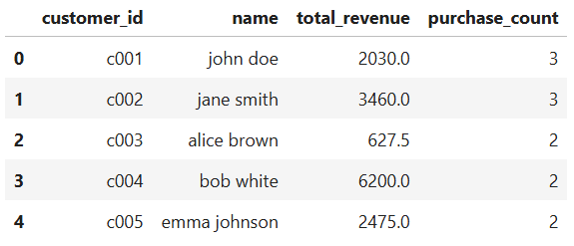

* Findings: bob white generated highest revenue.

**Sales Trends**

* Formatted the transaction_date in sales dataframe to datetime.
* Calculated month from transaction_date and saved it as column.
* Calculated total sales and num_transactions. Grouped by month
* Saved it in monthly sales dataframe.
* Plotted monthly sales using line chart in mathplotlib.

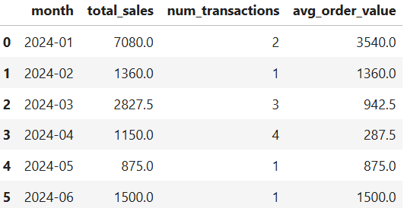

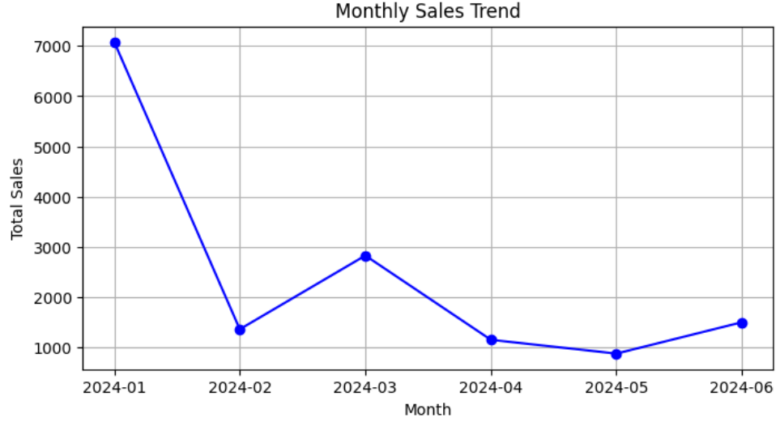

* Findings: highest sales in January month.

**Inventory Turnover Rate** to optimize stock levels.

* Calculated total revenue and units_sold. Grouped by product_id.
* Saved it in s dataframe.
* Merged the s and inventory dataframe based on product id column.
* Saved it in i dataframe.
* Dropped unwanted columns.
* Calculated turnover_rate based on units_sold * 100 / stock_quantity formula.
* Calculated stock_cover_days based on stock_quantity / units_sold formula.

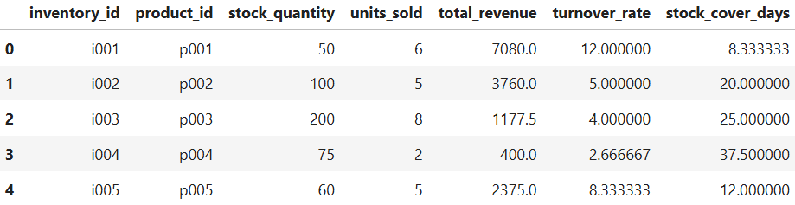

* Findings: Extremely fast turnover for inventory and product p001.

**Market Basket Analysis** for product recommendations.

* Calculated product frequency show often each product appears in transactions.
* Calculated customer purchase show many unique products each customer buys.
* Indicates customer shopping behaviour.
* Plotted Product Purchase Frequency using bar chart in mathplotlib.

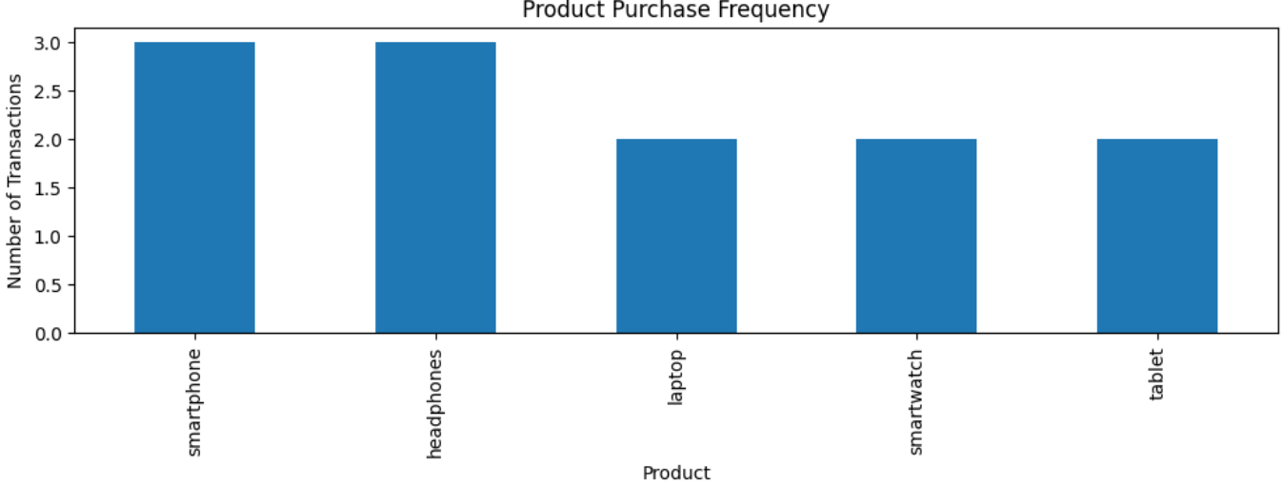

* Findings: smartphone and headphones appears in more transactions.

**Analytics & Reporting (Power BI Dashboards)**

* The 5 Tables in MYSQL Workbench are loaded into power query for transformation.
* The data types are changed for ID columns from number to text as there is no need of performing mathematical calculations.
* After transformation data is loaded into report.
* Goto Model view and check the relationships.
* Findings: I have checked the relations they are correctly established.

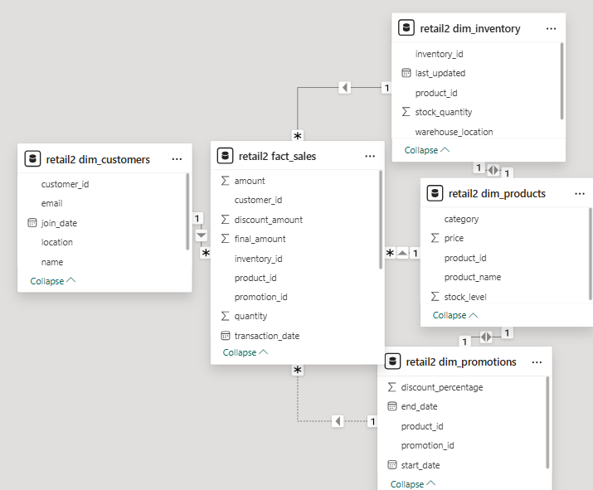

* I added title ‘**Retail Sales & Customer Insights Dashboard**’ using text box.

**Sales Performance Dashboard**

* Created measure ‘**total sales’**. Displayed using card visual under retail2 fact_ sales table

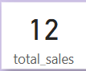 Findings: total number of sales are 12.

* Created measure ‘**total revenue**. Displayed using card visual under retail2 fact_ sales table

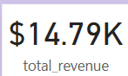 Findings: total revenue generated from sales is 14.79 thousand.

* Plotted **total revenue by month** using line chart.

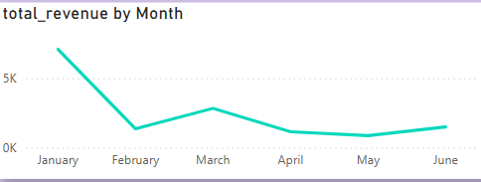

Findings: highest revenue generated from January month.

* Plotted Total revenue by product using clustered column chart.

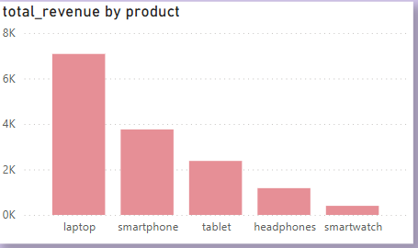 Findings: highest revenue generated from laptop.

**Customer Segmentation Dashboard**

* Plotted total sales and total revenue of customers using table visual.

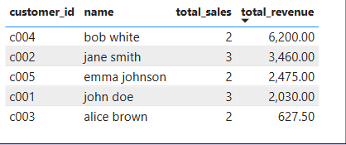 Findings: bob white generated highest revenue whereas jane and john have more sales.

**Inventory Optimization Dashboard** – Monitors stock levels and turnover rates.

* Created measure ‘**units sold’**. Based on total quantity sold under retail2 fact_ sales table
* Created measure ‘**turnover rate’.** Based onunits sold / sum of stock quantity underretail2 dim_inventory table.
* Displayed turnover rate for inventory using waterfall chart.

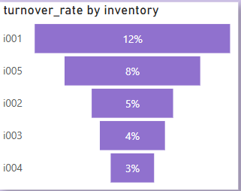 Findings: Extremely fast turnover for inventory i001. Need to restock regularly.

**Marketing Effectiveness Dashboard**

* Plotted discount percentage per product using donut chart.

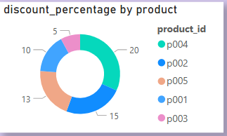 Findings: highest discount is on p004. Which is smartwatch.

* Created measure ‘**promoted revenue’**. Calculated sales with promotions. Displayed using card visual under retail2 fact_ sales table.

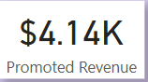 Findings: total revenue generated from promotion sales is 4.14 thousand.

* Created measure ‘**non** **promoted revenue’**. Calculated sales without promotions. Displayed using card visual under retail2 fact_ sales table.

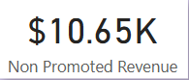 Findings: total revenue generated from non promotion sales is 10.65 thousand.

* Findings: non promoted revenue is more than promoted revenue which indicates promotions did not work.
* Plotted non promoted revenue and promoted revenue for products using stacked column chart.

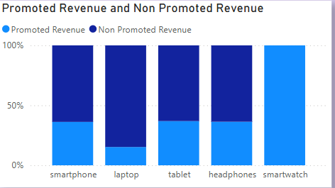 Findings: only for smartwatch the promotions worked and smartwatch has highest discount.

* Created slicer for category to filter all the visuals.

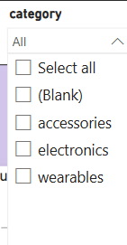

**Complete Report**

